TABLE OF CONTENTS

PROJECT SUMMARY

- Introduction
- Project Overview
- Grant Requests
- Public/Private Fundraising

ORGANIZATIONAL STRUCTURE

- PepsiCo’s Donation
- The Commission’s Loan of the Collection to the Museum
- Museum Lease

MUSEUM OPERATIONS

- Museum Staffing
- Museum and Tryon Palace

COLLECTION

- PepsiCo Donation

COMPARABLE EXHIBITS

- Ben & Jerry’s Factory Tour, Waterbury, VT
- Crayola Experience, Easton, PA
- Dr. Pepper Museum & Free Enterprise Institute, Waco, TX
- LEGO Millyard Project - SEE Science Center, Manchester, NH
- PEZ Visitor Center, Orange, CT
- The Hershey Story, Hershey, PA
- The Walmart Museum Heritage Lab, Bentonville, AR
- The Walmart Museum, Bentonville, AR
- World of Coca-Cola, Atlanta, GA

BUILDING DESIGN & RENOVATION

- Summary of Improvements
- MBF Architects PA, New Bern, NC
- Design Dimensions Inc., Raleigh, NC

TABLE OF CONTENTS (Continued)

ECONOMIC IMPACT

- Overview
- Annual Estimates

PROJECT SUMMARY

Introduction

New Bern was the colonial capital of North Carolina from 1766-1775, the state capital until 1792, and continues to be a voice of political influence for a period that has spanned 300+ years. Being located at the confluence of two rivers, on the original Post Road, and on an important rail line, New Bern experienced both the strife of war and benefits of commerce. These facts have led to a history that is politically rich, socially diverse, and filled with economic opportunities.

The invention of Pepsi Cola in New Bern is one of the most important economic and historical contributions to the City. A museum that highlights Pepsi’s history, its importance to New Bern, and some of its most iconic memorabilia gives New Bern the opportunity to share this important chapter in our history. The Museum will act as an economic driver to the City and particularly Greater Downtown*, assisting in its recovery from Hurricane Florence and COVID-19 which severely impacted the Greater Downtown community.

The proposed location of the Pepsi Museum is Downtown New Bern which is within six blocks of Five Points. Additionally, Caleb Bradham’s original and second drug stores are located downtown, and his house and the site of the first Pepsi manufacturing plant are within blocks of downtown. The downtown business district is also one block from the NC History Center and Tryon Palace.

Project Overview

Bradham’s Legacy, a 501(c)(3), is a North Carolina non-profit that was formed to be the governing body for a museum that will illustrate Pepsi’s historic ties and economic importance to New Bern, North Carolina. The proposed museum location is Downtown New Bern within close proximity of several significant Pepsi sites. Numerous artifacts (the “Collection”) have been donated to the Tryon Palace Commission (“Commission”) by a private donor and PepsiCo, Inc. (“PepsiCo”) has a second significant collection they intend to donate. The City of New Bern will assist in providing land and a building for the proposed museum. Swiss Bear, Inc. (“Swiss Bear”), a 501 (c)(3) that has implemented the Main Street program for the City of New Bern since 1980, is coordinating fund-raising efforts in keeping with its mission of facilitating economic development in Greater Downtown.

*Greater Downtown is defined as Downtown, the Pollock and Broad Street corridors connecting Downtown to Five Points, and Five Points.

PROJECT SUMMARY (Continued)

Grant Requests

Anticipated Grant Request

Rural Transformation Grant:

Recipient: | Pepsi Museum of New Bern
Amount: $950,000.00

Purpose: | The Grant funds will be used toward funding construction of a museum in downtown New Bern including design, construction materials, labor, and potentially installation of the exhibits.

Approved Grant

PepsiCo Foundation:

Recipient: | Pepsi Museum of New Bern
Amount: | $750,000
Purpose: | The Grant funds will be used toward building and exhibit design, and installation of the Museum’s exhibits at Hancock and South Front streets, New Bern, NC.

Public/Private Fundraising

Swiss Bear on behalf of Bradham’s Legacy will coordinate and implement a capital campaign to raise the remaining project funds. The remaining funds will be solicited through a combination of state/local foundations, and regional/local businesses and donors. It is projected that 99% of the funds needed will be obtained by corporate, foundation, and public grants as well as targeted private giving. The last 1% will be through small donations made by the public giving the public an opportunity to complete the fundraising and be engaged in the project.

ORGANIZATIONAL STRUCTURE

PepsiCo’s Donation

PepsiCo owns a substantial collection of objects associated with the history of the company that they desire to return to New Bern, the birthplace of Pepsi, under the control of the Commission. Additionally, Pepsi coordinated the donation of a substantial private collection that is already under the control of the Commission. Further, the company desires that the history of Pepsi be presented to the public visiting New Bern. To accomplish their goal, both collections will be donated to the Commission under an agreement between PepsiCo and the Commission.

The Commission’s Loan of the Collection to the Museum

The Commission, that oversees Tryon Palace’s extensive artifact and display collections, will loan the Collection to the Museum based on museum best practices, providing museum quality storage, cataloging and other oversight services as needed. The Commission and the Museum will enter into a Loan Agreement that will detail the use, storage, management, and facilitation of the PepsiCo donations’ use by the Museum. The Commission has all necessary tools to provide support for the maintenance of the Collection, and the Loan Agreement will outline the rights and responsibilities of the parties to maximize the beneficial use of the Collection for display and facilitation of the continuing efforts to attract thousands of visitors to New Bern.

Museum Lease

A lease agreement will be written to lease a facility for the Museum for an unspecified annual fee. Bradham’s Legacy believes that the City is receptive to the proposed lease due to the potential economic impact within the NC Opportunity Zone and within the Historic Downtown and Five Points area. An Opportunity Zone is an incentive for community investment established by Congress in the Tax Cuts and Jobs Act of 2017 to encourage long-term investments in low-income census tracks.

.

ORGANIZATIONAL STRUCTURE (Continued)

Transaction Chart

Revenue

Building
Collection
City
Commission
Museum
Grant Funds
Bradham’s
Legacy
PepsiCo
Rural Transformation Grant
Collection
Reinvestment in Museum,
Community Grants and Improvements

Grants and
Donations

Public/Private Fundraising
MUSEUM OPERATIONS

Museum Staffing

Staffing for the Museum should include a Director, Assistant Director, Interpreter, and Gift Shop Manager as full-time permanent staff. Additionally, for weekends, two part-time positions should be established.

The scale of the Museum is equivalent to a small state historic site. The positions, salaries and benefits below are based on the operation of a small historic site in the Department of Natural and Cultural Resources (salaries listed below are based on 2019 standards).

Director – Responsible for the overall management of the Museum.

Assistant Director – Fills in for the Director as needed and oversees the artifact collection and the overall maintenance of the Museum and its exhibits.

Interpreter – Greets visitors, provides overall security, and answers questions.

Gift Shop Manager – Oversees all operations of the Museum Shop including purchasing, inventory, sales, and merchandizing.

Position Salary Benefits* Total
Director $37,411 $16,022 $53,433
Assistant Director $33,960 $15,107 $49,067
Interpreter $31,200 $14,375 $45,575
Gift Shop Manager $33,960 $15,107 $49,067
Part time positions (2) $10/hour - 1,352 hours/year $13,520

Total $150,051 $60,611 $210,662

Museum and Tryon Palace

The Collection donated to the Commission will be stored in the Tryon Palace Annex on Pollock Street. The Collection will be made available to the Museum on a long-term loan basis. To catalogue and care for the Collection, Tryon Palace will need one ½-time position. A part-time Tryon Palace position with no benefits will be an additional annual cost of approximately $20,000 (salary is based on 2019 standards).

Total for all positions: $230,662 (based on 2019 standards).
* Benefits are for salaried employees and include retirement, health care and Social Security.
Bradham’s Legacy Board of Directors Composition

Eight (8) members of the Board of Directors will be designated representatives of the following organizations and may serve in that capacity for only so long as they continue to be part of that organization. The ninth member of the Board of Directors will be an At-large member.

- City of New Bern, Mayor or Designee
- City of New Bern, City Manager or Designee
- PepsiCo Designee
- PepsiCo Designee
- Swiss Bear, Executive Director or Designee
- Swiss Bear, Chairman or Designee
- Tryon Palace, Executive Director or Designee
- Tryon Palace, Chairman of Collections Committee or Designee
- At-large, elected by the other Directors

Additionally, up to six (6) additional At-large members of the Board of Directors may be elected who either demonstrate interest in the objectives and work of the Museum, or who represent identifiable relevant knowledge that would assist the Museum in its purpose.

The director of the Pepsi Museum of New Bern reports to the Board.

COLLECTION

PepsiCo Donation

PepsiCo has come into possession of a valuable private collection of historic objects and memorabilia associated with the history of the Company and desires to have these objects returned to New Bern, the birthplace of Pepsi. Further, the Company desires that the history of Pepsi be presented to the public visiting New Bern.

Additionally, Pepsi coordinated the donation of a second significant private collection that is already under the control of the Commission.

Below are several photographs of items representative of the contents in the collections.

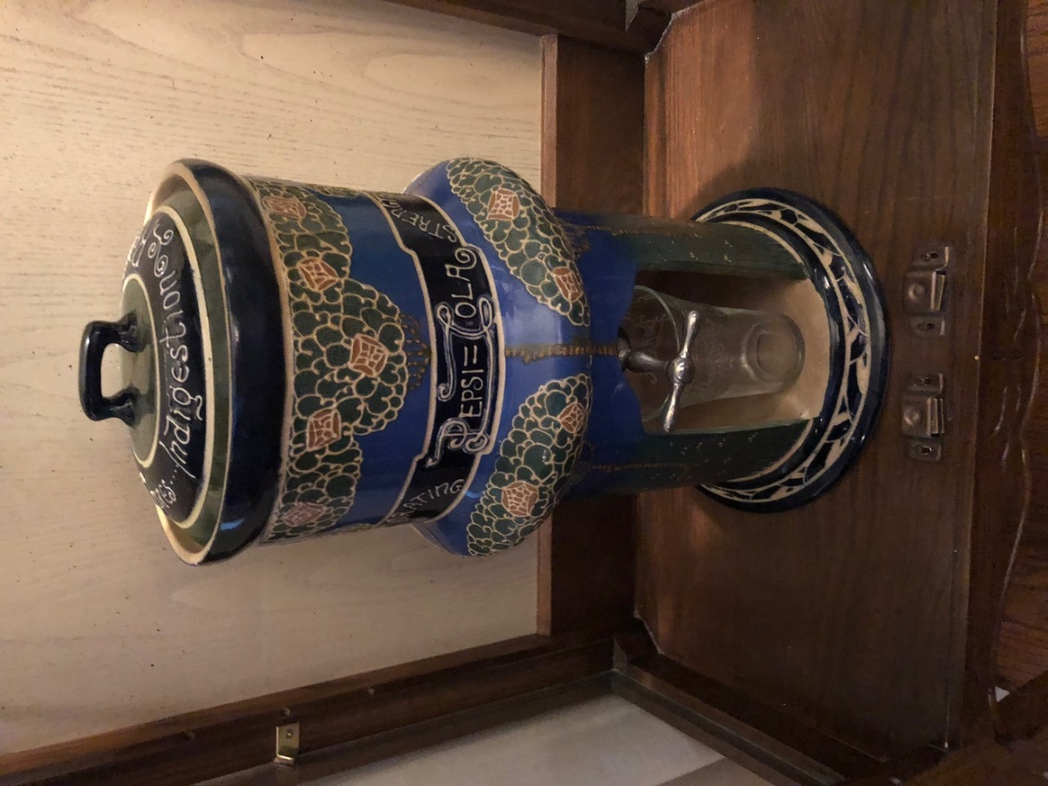

COLLECTION (Continued)

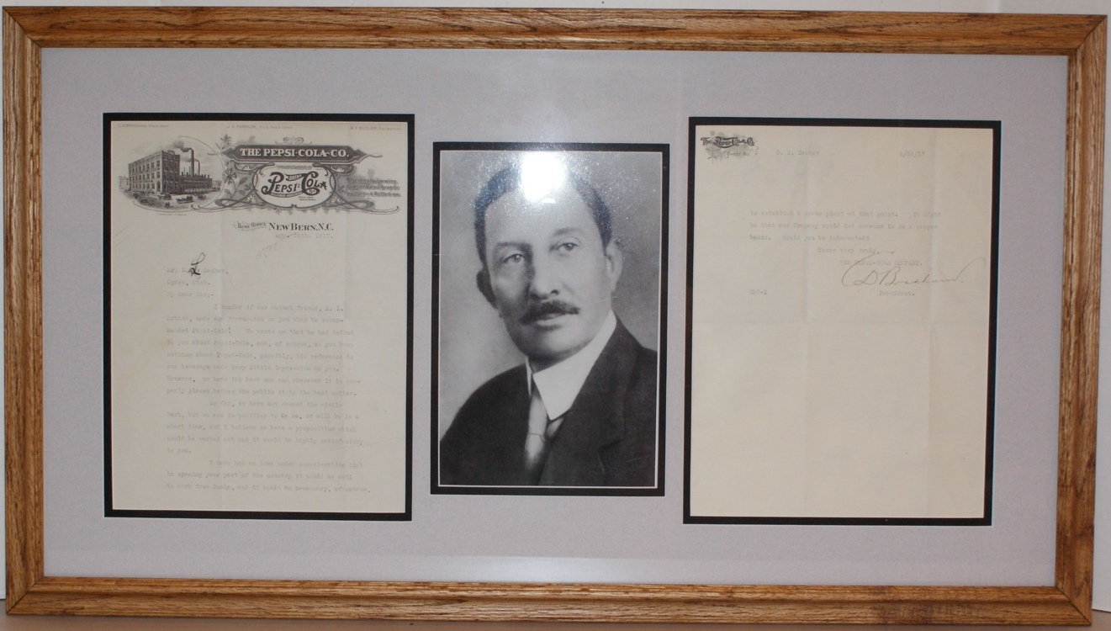

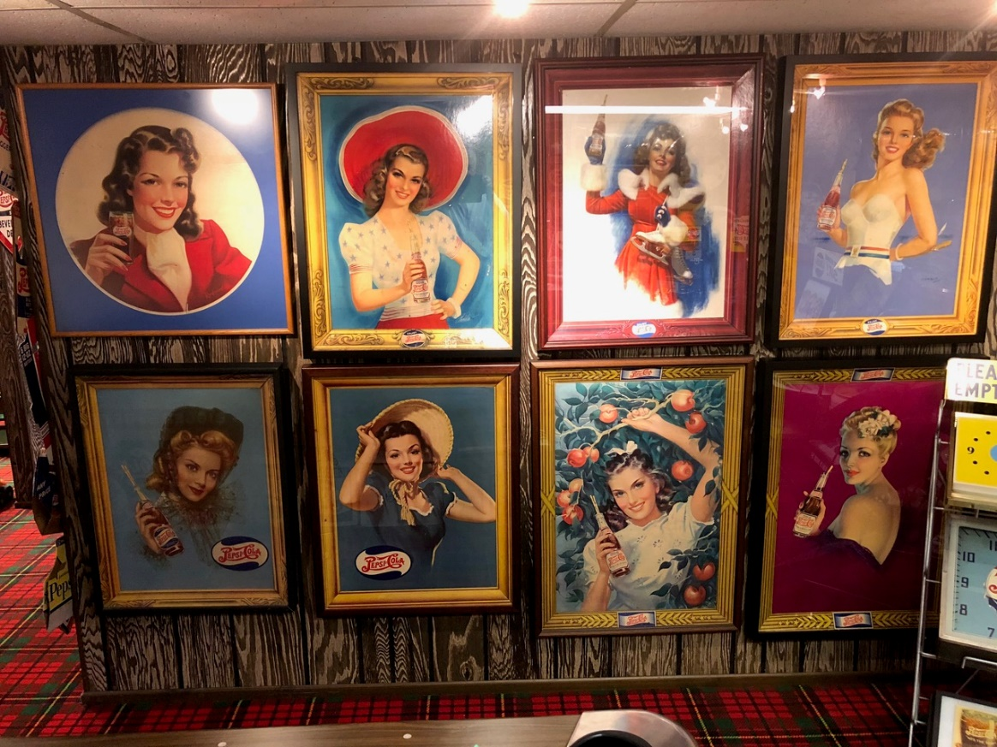

COLLECTION (Continued)

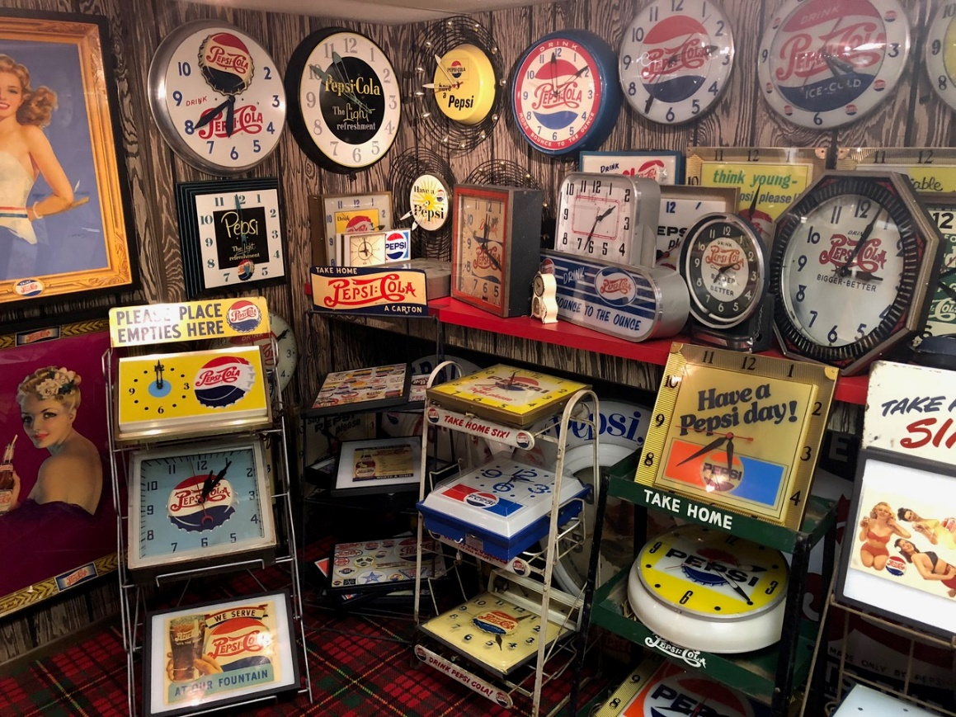

COMPARABLE EXHIBITS

In considering the feasibility of the Museum in New Bern, a number of potentially comparable museums featuring iconic brands were evaluated. Most are from a “Top Ten” list of company museums. The ones we studied are as follows:

Ben & Jerry’s Factory Tour, Waterbury, VT
- $6 Adult (13 - 64), $5 Senior (65+), $1 children (12 and under)
- 350,000 annual attendance
- Produce product on site
- 10 - 20 miles from larger cities
- Hosts events as well as tours
- Waterbury has a Population of 5,320 (2021)
Crayola Experience, Easton, PA
- $28.99 at door, $25.99 online General Admission (3+)
- No published attendance and unwilling to share
- Very large facility, 65,000 Sq. Ft.
- Highly interactive
- City of Easton population of 28,057 (2021) and is located mid-way between NYC and Philadelphia
Dr. Pepper Museum & Free Enterprise Institute, Waco, TX
- $10 Adult (ages not given), children 4 years and under free
- Opened in 1991 and has attracted over a million visitors; no current figures
- Displays equipment but does not actually bottle
- Also functions as a Free Enterprise Institute; builds on life and values of founder
- Waco has a population of 139,594 (2021)
LEGO Millyard Project - SEE Science Center, Manchester, NH
- $12 (3+).
- Reached 150,000 attendance in 2007
- Heavy influence on science and education and robotics
- Seems to be non-profit, originally financed by a Community Block Grant
- Hosts many events
- Manchester has a population of 115,462 (2021)

COMPARABLE EXHIBITS (Continued)

PEZ Visitor Center, Orange, CT
- $5 Adult, $4 Senior (60+), $4 Children (3 – 12), free (0 - 3)
- 100,000 visitors annually
- Features actual production as well as tours
- Hosts events and school visits
- Orange has a population of 14,246 (2021)
The Hershey Story, Hershey, PA
- Museum Experience $16.50 Adult (13 - 61), $15.50 Senior (62+), $12.50 Junior (3 - 12), Active Duty Military FREE
- No attendance figures
- Is separate from the amusement park but located adjacent to the park
- Some exhibits on chocolate but seems heavily focused on Mr. Hershey, his life and Hershey family contributions
- Hershey has a population of 13,858 (2020)
The Walmart Museum Heritage Lab, Bentonville, AR
- Free admission
- No attendance figures
- Located in the original Walmart store in Bentonville
- Tells the story of Walmart and has a soda fountain
- Bentonville has a population of 56,734 (2021)
The Walmart Museum, Bentonville, AR
- Free admission – currently under renovation through Spring 2024
- No attendance figures
- Located in the original Walmart store in Bentonville
- Tells the story of Walmart and has a soda fountain
- Bentonville has a population of 56,734 (2021)

World of Coca-Cola, Atlanta, GA
- $19 Adult (13 - 64), $17 Senior (65+), $15 Youth (3-12), free (0 - 2 with adult)
- 20-acre facility opened in 2007, previous facility drew one million plus annually
- Many other locations
- Atlanta metropolitan area has a population of 5,911,000 (2021)

COMPARABLE EXHIBITS (Continued)

Most of the comparable museums are iconic in the food and beverage industry with two (2) being outside of the industry. All are established museums. Attendance varies from 100,000 to 350,000 for those with published figures. Entrance fees vary from free to $20. In looking at the most comparable in size, offerings, ticket price, and location in terms of proximity to population centers, the Pepsi Museum attendance projections appear to be well within range. In addition to giving guidance on expected visitation, a great deal of information was gained about the makeup, offerings, and operation of these successful museums.

BUILDING DESIGN & RENOVATION

Location

The museum would be located in the Downtown New Bern Historic District, a NC Opportunity Zone, and would be approximately six blocks from Five Points. It would also be in close proximity to four important and historic Pepsi sites.

Summary of the Museum Facility

The proposed facility would be between 6000-8000 square feet. The majority of the space will be utilized for an exhibit area with a tasting room that can be opened to access an exterior courtyard that might be used for such things as a patio with table seating and outdoor displays. Approximately 500 square feet will be used for an office and small meeting room. Toilets and other service areas will require approximately another 500 square feet. Detailed design plans will be developed in 2023 once the site is secured.

Regarding exhibit space, basic static exhibits cost approximately $500/square foot (based on 2019 estimates). Exhibits that are environmental, have interactive components and incorporate multimedia are $1,000/square foot or more (based on 2019 estimates). The more complex the exhibit, the more technical support it will require for daily maintenance. Assuming approximately 4,000 square feet of exhibits, museum quality work, as estimated by Design Dimensions Inc., would range from $ 1.5 to $2.4 million (based on 2019 estimates). Maintenance of technology and interactive exhibits need to be calculated.

BUILDING DESIGN & RENOVATION (Continued)

MBF Architects PA, New Bern, NC

MBFA is a full-service architectural firm established in September of 1993. The firm offers comprehensive professional services for the programming, design and documentation of new construction projects, renovation of existing facilities and historic preservation.

The outstanding level of service and client satisfaction achieved by MBFA is measured by hundreds of projects completed or in process. Clients such as Weyerhaeuser Real Estate, the Naval Facilities Engineering Command, Tryon Palace Historic Sites and Gardens, Carteret County Schools and others have demonstrated their satisfaction and confidence in MBFA by selecting the firm for multiple projects. MBFA has the experience, the commitment, and the enthusiasm to insure the highest level of design quality and client satisfaction.

MBFA is invested in the New Bern community both through our extensive professional work as well as giving back through community service. Staff members have shared their skill and expertise with various community organizations such as Swiss Bear, Inc., the New Bern Area Chamber of Commerce, the New Bern Preservation Foundation as well as governmental and other non-profit boards.

A brief listing of MBF Architects PA project experience includes:

- New Bern Riverfront Convention Center, New Bern, NC
- The Pepsi Store, New Bern NC
- Havelock Tourist and Events Center, Havelock, NC
- Conservatory Renovation, North Carolina Aquarium, Manteo, NC
- Visitor Center, Camp Lejeune Marine Corps Base, NC
- Visitor Center and Chamber of Commerce Offices, New Bern, NC

BUILDING DESIGN & RENOVATION (Continued)

Design Dimensions Inc., Raleigh, NC

Design Dimension is a North Carolina-based company that has been serving the southeast for over 51 years. Established in 1967, as an industrial design consulting firm by Wayne Poole, Design Dimension has since grown steadily in size and scope. In 2018 Lead Designer, Betsy Peters Rascoe, acquired the company to carry on the legacy. With 7 full-time employees, it offers a full range of design and production services that cater to a wide variety of regional, national, and international clients. These services include museum design and planning, educational and interactive exhibits, prototypes/models, graphics, wayfinding, as well as custom fabrications for museums, visitor centers, and corporate environments.

The company’s focus is on building a team of personnel and equipment to enable it to take a project from conception to finished product. The staff analyze each client’s problems and ideas to pinpoint their needs through discussion, presentation rendering, modeling, and mechanical drawing. Design, fabrication, and graphic production are done in-house to maintain firm control of cost, schedule, and quality. The company’s facility allows it to fabricate almost anything - from high-tolerance machining in metal and plastic to custom furnishings and casework of natural wood and plastic laminate.

The majority of the company’s business comes as referrals from satisfied clients. Word-of-mouth referrals indicate relationships based on trust, honesty, professionalism, and a commitment to quality. The company and its staff are avid proponents of community involvement in design approach, and they have witnessed first-hand how practicing this philosophy enriches both museums and the communities they serve. Whether through oral histories, donations of photos or artifacts, or workshops with the design team, there are many ways local communities can get involved in the exhibit process. This community involvement is a “win-win” situation that not only adds local character and flair, but also fosters further community support, enhances repeat visitation and makes the museum a part of the fabric of the community.

Airborne & Special Operations Museum, Fayetteville, NC
Cone Mills “The Fabric of Memory”, Greensboro, NC
Gorges State Park Visitor Center, Sapphire, NC
H.L. Hunley Conservation Lab, Charleston, SC
Roanoke Canal Trail and Museum, Roanoke Rapids, NC
Wilson Whirligig Park Signage and Wayfinding, Wilson, NC
New Bern Historical Society 100th Anniversary Exhibit, Tryon Palace, New Bern, NC

ECONOMIC IMPACT

Overview

Tryon Palace and the New Bern-Craven County Convention & Visitor Center believe there is a strong desire by the visiting public for a Pepsi Museum based on interaction between guests and the ticketing staff at Tryon Palace and inquiries at the Visitor Center. They estimate that a Pepsi Museum of high quality would command an average ticket price of $8 per person. It is possible to reach or exceed annual visitation of 50,000. Museum revenues should cover the staffing and operating costs of the Museum. Below are the economic impact estimates that the New Bern-Craven County Convention & Visitor Center generated in conjunction with Tryon Palace.

Annual estimates*
Lodging $ 3,056,779
Transportation (gas, air, bus, etc.) Food & Beverage $ 830,700
Retail $ 244,367
Other (Recreation, Rental, and Services) $ 1,982,450
Total Local Sales $ 6,114,296
New FTE Jobs 13
New PT Jobs 34

*Economic impact estimates obtained through Craven County Tourism and Development Authority

