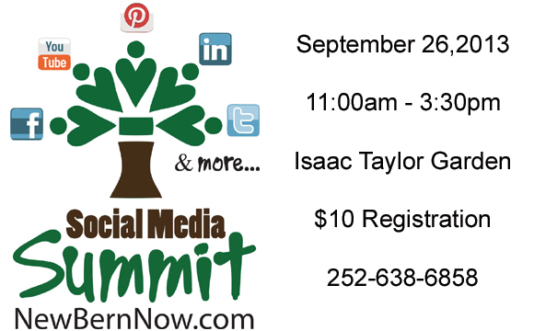
Event Registration Form

First Name, Last Name: __________________________________ Date: ___________

Business or Nonprofit Name: ______________________________________________

Address: ______________________________________________________________

Email address: ____________________________ Phone number: _______________

Website: ______________________________________________________________

Facebook: _______________________________ Twitter page: __________________

Youtube channel:__________________________ Other social media pages: ________

______________________________________________________________________

What social media sites do you spend the most time on (i.e. Facebook, Twitter, LinkedIn, Instagram, Youtube, Pinterest, etc.): _________________________________

______________________________________________________________________

What do you want to learn from the Social Media Summit?:_______________________

______________________________________________________________________

Registration cost: $10 which includes lunch, beverages, chances to win door prizes, CD with social media information along with contacts and more. Attendees will also be promoted in an article about the Summit to include a link to your online presence.

Please print this form out, make checks payable to “NC Life Media LLC”, and send them to P.O. Box 13614, New Bern, NC 28561. Or save postage by dropping it off at the Isaac Taylor House, 228 Craven St. Please give us a call at 252-638-6858 or send an email to wendycard@nclifemedia.com with any questions.

